CONTROLLER

**REGISTER.PHP**

<?php  
  
*defined*('BASEPATH') OR exit('No direct script access allowed');  
  
class Register extends CI_Controller  
{  
 public function __construct()  
 {  
 parent::*__construct*();  
 *//IST EIN USER IN DIESER SESSION EINGELOGGT -> PRIVATER BEREICH* if ($this->session->userdata('id')) {  
 redirect('private_area');  
 }  
 $this->load->helper(["form", "url"]);  
 $this->load->library('form_validation');  
 $this->load->model('register_model');  
 }  
  
 public function index()  
 {  
 $this->load->view("view_register");  
 }  
  
 public function validation()  
 {  
 *//VALIDIERUNGSREGELN ANLEGEN* $this->form_validation->set_rules("usernamereg", "Username", ['required']);  
 $this->form_validation->set_rules("firstname", "First Name", ['required']);  
 $this->form_validation->set_rules("lastname", "Last Name", ['required']);  
 $this->form_validation->set_rules("password1reg", "Password", ['required', 'min_length[8]']);  
 $this->form_validation->set_rules("password2reg", "Repeat", ['required', 'matches[password1reg]']);  
  
 *//VALIDIERUNGSREGELN WERDEN ERFÜLLT?* if ($this->form_validation->run() != FALSE) {  
 *//ÜBERPRÜFUNG: GIBT ES USERNAMEN BEREITS?* if (empty($this->register_model->exists($this->input->post('usernamereg')))) {  
 *//PASSWORT VERSCHLÜSSELN* $encrypted_password = *md5*($this->input->post("password1reg"));  
 $aData = [  
 'username' => $this->input->post('usernamereg'),  
 'firstname' => $this->input->post('firstname'),  
 'lastname' => $this->input->post('lastname'),  
 'password' => $encrypted_password  
 ];  
 *//EINFÜGEN IN DATENBANK* $this->register_model->insert($aData);  
 echo "<p class='notify green'>Registration successful!</p>";  
 }  
 else  
 echo "<p class='notify red'>Username already exists!</p>";  
 $this->index();  
 }

else {  
 *//FEHLERFALL: MITGABE EINGEGEBENER DATEN* $aData = $aData = [  
 'username' => $this->input->post('usernamereg'),  
 'firstname' => $this->input->post('firstname'),  
 'lastname' => $this->input->post('lastname'),  
 ];  
 $this->load->view("view_register", $aData);  
 }  
 }  
}

**LOGIN.PHP**

<?php  
  
*defined*('BASEPATH') OR exit('No direct script access allowed');  
  
class Login extends CI_Controller  
{  
 public function __construct()  
 {  
 parent::*__construct*();  
 *//IST EIN USER IN DIESER SESSION EINGELOGGT -> PRIVATER BEREICH* if($this->session->userdata('id'))  
 {  
 redirect('private_area');  
 }  
 $this->load->library('form_validation');  
 $this->load->model('login_model');  
 }  
 public function index()  
 {  
 $this->load->view('view_login');  
 }  
  
 public function validation()  
 {  
 *//VALIDIERUNGSREGELN ANLEGEN* $this->form_validation->set_rules("username", "Username",['required']);  
 $this->form_validation->set_rules("password", "Password",['required']);  
  
 *//VALIDIERUNGSREGELN WERDEN ERFÜLLT?* if($this->form_validation->run())  
 {  
 *//ÜBERPRÜFUNG EINGABEDATEN MIT DB DATEN* $result = $this->login_model->login($this->input->post('username'), $this->input->post('password'));  
 if($result == '')  
 {  
 *//KORREKTE DATEN* redirect('private_area');  
 }  
 else  
 {  
 *//INKORREKTE DATEN* echo "<p class='notify red'>".$result."</p>";  
 $this->index();  
 }  
 }

*//FEHLERFALL: MITGABE EINGEGEBENER DATEN* else {  
 $aData = $aData = [  
 'username' => $this->input->post('username'),  
 ];  
 $this->load->view("view_login", $aData);  
 }  
 }  
}

**PRIVATE_AREA.PHP**

<?php  
*defined*('BASEPATH') OR exit('No direct script access allowed');  
  
class Private_Area extends CI_Controller  
{  
 public function __construct(){  
 parent::*__construct*();  
 if(!$this->session->userdata('id'))  
 {  
 redirect('login');  
 }  
 }  
  
 function index(){  
 $this->load->view("view_private");  
 }  
  
 function logout(){  
 *//BEI LOGOUT WERDEN ALLE DATEN IN DER SESSION GELÖSCHT* $data = $this->session->all_userdata();  
 foreach($data as $row => $rows_value)  
 {  
 $this->session->unset_userdata($row);  
 }  
 redirect('login');  
 }  
}

MODEL

**REGISTER_MODEL.PHP**

<?php  
  
  
class Register_Model extends CI_Model  
{  
 function insert($aData)  
 {  
 $this->db->insert('user', $aData);  
 return $this->db->insert_id();  
 }  
  
 function exists($sUsername)  
 {  
 $sQuery = "SELECT username FROM user WHERE username='".$sUsername."';";  
 *//durch Autoload der Library db Zugriff möglich* $mResult = $this->db->query($sQuery);  
 return $mResult->result();  
 }  
}

**LOGIN_MODEL.PHP**

<?php  
  
  
class Login_Model extends CI_Model  
{  
 function login($username, $password)  
 {  
 $this->db->where('username', $username);  
 $query = $this->db->get('user');  
 *//ÜBERPRÜFUNG ÜBEREINSTIMMUNG USERNAME* if($query->num_rows() > 0) {  
 foreach ($query->result() as $row) {  
 $store_password = *md5*($password);  
 *//ÜBERPRÜFUNG ÜBEREINSTIMMUNG PASSWORT* if ($row->password == $store_password) {  
 $this->session->set_userdata('id', $row->userid);  
 } else {  
 return 'Wrong Password!';  
 }  
 }  
 }  
 else  
 return 'Wrong Username!';  
 }  
}

VIEW

**VIEW_LOGIN.PHP**

<?php  
*defined*('BASEPATH') OR exit('No direct script access allowed');  
  
if($this->session->userdata('id'))  
 redirect('private_area');  
else{  
?>  
  
<!DOCTYPE html>  
<html lang="en">  
<head>  
 <meta charset="utf-8">  
 <title>HÜ 7 - CodeIgniter</title>  
 <link rel="stylesheet" type="text/css" href="<?=base_url();?>css/style.css"/>  
 <link rel="stylesheet" href="https://stackpath.bootstrapcdn.com/bootstrap/4.4.1/css/bootstrap.min.css" integrity="sha384-Vkoo8x4CGsO3+Hhxv8T/Q5PaXtkKtu6ug5TOeNV6gBiFeWPGFN9MuhOf23Q9Ifjh" crossorigin="anonymous">  
</head>  
<body>  
  
  
<div class="login_form">  
 <div>  
 <h3>Login:</h3>  
 <?php  
 *//SERVERSEITIGE FORMULARVALIDIERUNG* echo validation_errors();  
  
 *//LOGIN-FORM* echo form_open(base_url().'index.php/login/validation');  
  
 *//Username* echo form_label("Username:", "username");  
 $usernameInput = array("value" => set_value("username"),  
 "name" => "username",  
 "id" => "username");  
 echo (form_input($usernameInput)."<br>");  
  
 *//Password* echo form_label("Password:", "password");  
 $passwordInput = array(  
 "name" => "password",  
 "id" => "password");  
 echo (form_password($passwordInput)."<br>");  
  
 *//Submit-Button* $submitInput = array("value" => "Login",  
 "class" => "login_button");  
 echo form_submit($submitInput);  
  
 echo form_close();  
 ?>  
  
 <a href="<?php echo base_url();?>index.php/register">Want to Register?</a>  
 </div>  
</div>  
</body>  
</html>  
<?php  
}  
?>

**VIEW_REGISTER.PHP**

<?php  
*defined*('BASEPATH') OR exit('No direct script access allowed');  
  
?><!DOCTYPE html>  
<html lang="en">  
<head>  
 <meta charset="utf-8">  
 <title>HÜ 7 - CodeIgniter</title>  
 <link rel="stylesheet" type="text/css" href="<?=base_url();?>css/style.css"/>  
 <link rel="stylesheet" href="https://stackpath.bootstrapcdn.com/bootstrap/4.4.1/css/bootstrap.min.css" integrity="sha384-Vkoo8x4CGsO3+Hhxv8T/Q5PaXtkKtu6ug5TOeNV6gBiFeWPGFN9MuhOf23Q9Ifjh" crossorigin="anonymous">  
</head>  
<body>  
  
<div class="registration_form">  
 <div>  
 <h3>Registration:</h3>  
 <?php  
  
 *//SERVERSEITIGE FORMULARVALIDIERUNG* echo validation_errors();  
  
 *//LOGIN-FORM* echo form_open(base_url().'index.php/register/validation');  
  
 *//Username* echo form_label("Username:", "usernamereg");  
 $usernameInput = array("value" => set_value('usernamereg'),  
 "name" => "usernamereg",  
 "id" => "usernamereg");  
 echo (form_input($usernameInput)."<br>");  
  
 *//Vorname* echo form_label("First Name:", "firstname");  
 $firstnameInput = array("value" => set_value('firstname'),  
 "name" => "firstname",  
 "id" => "firstname");  
 echo (form_input($firstnameInput)."<br>");  
  
 *//Nachname* echo form_label("Last Name:", "lastname");  
 $lastnameInput = array("value" => set_value('lastname'),  
 "name" => "lastname",  
 "id" => "lastname");  
 echo (form_input($lastnameInput)."<br>");  
  
 *//Password 1* echo form_label("Password:", "password1reg");  
 $password1Input = array(  
 "name" => "password1reg",  
 "id" => "password1reg");  
 echo (form_password($password1Input)."<br>");

*//Password 2* echo form_label("Repeat:", "password2reg");  
 $password2Input = array(  
 "name" => "password2reg",  
 "id" => "password2reg");  
 echo (form_password($password2Input)."<br>");  
  
 *//Submit-Button* $submitInput = array("value" => "Register",  
 "class" => "reg_button");  
 echo form_submit($submitInput);  
  
 echo form_close();  
 ?>  
  
 <a href="<?php echo base_url();?>index.php/login">Want to Login?</a>  
 </div>  
</div>  
  
</body>  
</html>

**VIEW_PRIVATE.PHP**

<?php  
*defined*('BASEPATH') OR exit('No direct script access allowed');  
?><!DOCTYPE html>  
<html lang="en">  
<head>  
 <meta charset="utf-8">  
 <title>HÜ 7 - CodeIgniter</title>  
 <link rel="stylesheet" type="text/css" href="<?=base_url();?>css/style.css"/>  
 <link rel="stylesheet" href="https://stackpath.bootstrapcdn.com/bootstrap/4.4.1/css/bootstrap.min.css" integrity="sha384-Vkoo8x4CGsO3+Hhxv8T/Q5PaXtkKtu6ug5TOeNV6gBiFeWPGFN9MuhOf23Q9Ifjh" crossorigin="anonymous">  
</head>  
<body>  
  
<h1 class="welcomeUser">Welcome! You are now logged in</h1>  
  
<a href="<?php echo base_url()?>index.php/private_area/logout" class="logout_button">Logout</a>  
  
</body>  
</html>

CSS

body{  
 height: 100vh;  
 font-family: "Bahnschrift", sans-serif;  
 box-sizing: border-box;  
 background: url("../img/bg.jpg");  
 display: flex;  
 flex-wrap: wrap;  
 gap: 5%;  
 justify-content: center;  
 align-items: center;  
}  
  
.welcome{  
 width: 100%;  
 background-color: #fff;  
 text-align: center;  
 color: #5e8949;  
 padding: 10px;  
 border-bottom: 8px solid #5e8949;  
}  
  
.welcomeUser{  
 display: block;  
 color: white;  
 font-size: 40pt !important;  
}  
  
h1, h2{  
 margin: 0;  
 font-size: 28px !important;  
}  
  
.title{  
 text-align: left;  
 font-size: 18px !important;  
}  
  
.login_form, .registration_form{  
 display: flex;  
 justify-content: center;  
 height: auto;  
 padding: 20px 50px 5px 50px;  
 background-color: white;  
 width: 400px;  
 border-radius: 10px;  
}  
  
.login_form p, .registration_form p{  
 color: red;  
}  
  
.registration_form h3, .login_form h3{  
 margin-bottom: 20px;  
}

.registration_form a, .login_form a{  
 display: block;  
 color: #5e8949;  
 text-align: center;  
 margin-bottom: 30px;  
}  
  
.registration_form a:hover, .login_form a:hover{  
 color: #6eaa69;  
 transition: 0.5s ease;  
}  
  
i{  
 color: red;  
}  
  
.notify{  
 display: block;  
 width: 100vw;  
 background-color: white;  
 font-size: 20px;  
 text-align: center;  
 padding: 20px 0 20px 0;  
}  
  
.red{  
 color: red;  
}  
  
.green{  
 color: green;  
}  
  
form input, form a{  
 box-sizing: border-box;  
 border-radius: 5px;  
 border: 1px solid #999;  
 padding: 4px;  
 outline: none;  
}  
  
.reg_button, .login_button, .logout_button{  
 font-size: 1.1em;  
 padding: 10px;  
 font-family: Roboto, sans-serif;  
 font-weight: 300;  
 color: #fff;  
 background-color: #5e8949;  
 border-radius: 20px;  
 cursor: pointer;  
 margin-bottom: 2em;  
 margin-top: 15px;  
}  
  
.toDoList{  
 width: 100%;  
 padding: 2%;  
 display: flex;  
 gap: 50px;  
 flex-wrap: wrap;  
 justify-content: center;  
}

.entry{  
 display: flex;  
 justify-content: space-evenly;  
 flex-direction: column;  
 background-color: #fff;  
 color: #5e8949;  
 padding: 30px;  
 border-radius: 20px;  
 font-size: 13px;  
 width: 400px;  
}  
  
.entry h3{  
 margin-bottom: 20px;  
}  
  
.status{  
 background-color: #aaa;  
 color: #fff;  
 padding: 20px;  
 text-transform: uppercase;  
 margin-bottom: 20px;  
 font-size: 15px;  
 text-align: center;  
}  
  
.note{  
 color: #aaa;  
 font-size: 14px;  
 margin-bottom: 20px;  
}  
  
.buttons{  
 display: flex;  
 justify-content: center;  
 gap: 20px;  
 text-align: center;  
}  
  
.delete, .edit, .finish{  
 background-color: #aaa;  
 color: #fff;  
 padding: 10px;  
 border-radius: 10px;  
 cursor: pointer;  
 font-size: 15px;  
 border: none;  
 width: 30%;  
 text-decoration: none;  
}  
  
label{  
 width: 100px;  
}  
  
input{  
 display: inline-block;  
 margin: 2px;  
}  
  
.error{  
 border-color: red;  
}

.form-style-5{  
 max-width: 500px;  
 background: #f4f7f8;  
 margin: 10px auto;  
 padding: 20px;  
 border-radius: 8px;  
}  
.form-style-5 fieldset{  
 border: none;  
}  
.form-style-5 legend {  
 font-size: 1.4em;  
 margin-bottom: 10px;  
}  
.form-style-5 label {  
 display: block;  
 margin-bottom: 8px;  
}  
.form-style-5 input[type="text"],  
.form-style-5 textarea{  
 background: rgba(255,255,255,.1);  
 border: none;  
 border-radius: 4px;  
 font-size: 15px;  
 outline: 0;  
 padding: 10px;  
 width: 100%;  
 box-sizing: border-box;  
 -webkit-box-sizing: border-box;  
 -moz-box-sizing: border-box;  
 background-color: #e8eeef;  
 color:#8a97a0;  
 -webkit-box-shadow: 0 1px 0 rgba(0,0,0,0.03) inset;  
 box-shadow: 0 1px 0 rgba(0,0,0,0.03) inset;  
 margin-top: 20px;  
}  
.form-style-5 input[type="text"]:focus,  
.form-style-5 textarea:focus{  
 background: #d2d9dd;  
}  
.form-style-5 select{  
 height:35px;  
}  
.form-style-5 .number {  
 background: #5e8949;  
 color: #fff;  
 height: 30px;  
 width: 30px;  
 display: inline-block;  
 font-size: 0.8em;  
 margin-right: 4px;  
 line-height: 30px;  
 text-align: center;  
 text-shadow: 0 1px 0 rgba(255,255,255,0.2);  
 border-radius: 15px 15px 15px 0px;  
}

.form-style-5 input[type="submit"],  
.form-style-5 input[type="button"]  
{  
 position: relative;  
 display: block;  
 padding: 19px 39px 18px 39px;  
 color: #FFF;  
 margin: 0 auto;  
 background: #5e8949;  
 font-size: 18px;  
 text-align: center;  
 font-style: normal;  
 width: 100%;  
 border: 1px solid #5e8949;  
 border-width: 1px 1px 3px;  
 margin-bottom: 10px;  
}

.form-style-5 input[type="submit"]:hover,  
.form-style-5 input[type="button"]:hover,  
.delete:hover, .edit:hover, .finish:hover, .logout_button:hover,  
.login_button:hover, .reg_button:hover{  
 color: white;  
 text-decoration: none;  
 background: #6eaa69;  
 transition: 0.5s ease;  
}  
  
.logout_button{  
 font-size: 30pt !important;  
 margin-bottom: 0;  
 background-color: whitesmoke;  
 color: #5e8949;  
}

GEÄNDERTE DATEIEN (CONFIG)

Habe hier teilweise nur Ausschnitte reingegeben, damit ersichtlicher wird, was ich geändert habe 😊

DATABASE.PHP

<?php  
*defined*('BASEPATH') OR exit('No direct script access allowed');  
 *\*/*$active_group = 'default';  
$query_builder = TRUE;  
  
$db['default'] = array(  
 'dsn' => '',  
 'hostname' => 'localhost',  
 'username' => 'kwm226_ue07_schickmair',  
 'password' => '.kwm.',  
 'database' => 'kwm226_ue07_schickmair',  
 'dbdriver' => 'mysqli',  
 'dbprefix' => '',  
 'pconnect' => FALSE,  
 'db_debug' => (*ENVIRONMENT* !== 'production'),  
 'cache_on' => FALSE,  
 'cachedir' => '',  
 'char_set' => 'utf8',  
 'dbcollat' => 'utf8_general_ci',  
 'swap_pre' => '',  
 'encrypt' => FALSE,  
 'compress' => FALSE,  
 'stricton' => FALSE,  
 'failover' => array(),  
 'save_queries' => TRUE  
);

CONFIG.PHP

<?php  
*defined*('BASEPATH') OR exit('No direct script access allowed');  
  
*/*  
|--------------------------------------------------------------------------  
| Base Site URL  
|--------------------------------------------------------------------------  
|  
| URL to your CodeIgniter root. Typically this will be your base URL,  
| WITH a trailing slash:  
|  
| http://example.com/  
|  
| WARNING: You MUST set this value!  
|  
| If it is not set, then CodeIgniter will try guess the protocol and path  
| your installation, but due to security concerns the hostname will be set  
| to $_SERVER['SERVER_ADDR'] if available, or localhost otherwise.  
| The auto-detection mechanism exists only for convenience during  
| development and MUST NOT be used in production!  
|  
| If you need to allow multiple domains, remember that this file is still  
| a PHP script and you can easily do that on your own.  
|  
*/*$config['base_url'] = 'http://localhost/SWP/HUE07';

AUTOLOAD.PHP

<?php  
*defined*('BASEPATH') OR exit('No direct script access allowed');  
  
  
*/*  
| -------------------------------------------------------------------  
| Auto-load Libraries  
| -------------------------------------------------------------------  
| These are the classes located in system/libraries/ or your  
| application/libraries/ directory, with the addition of the  
| 'database' library, which is somewhat of a special case.  
|  
| Prototype:  
|  
| $autoload['libraries'] = array('database', 'email', 'session');  
|  
| You can also supply an alternative library name to be assigned  
| in the controller:  
|  
| $autoload['libraries'] = array('user_agent' => 'ua');  
*/*$autoload['libraries'] = array("session","database");  
  
  
*/*  
| -------------------------------------------------------------------  
| Auto-load Helper Files  
| -------------------------------------------------------------------  
| Prototype:  
|  
| $autoload['helper'] = array('url', 'file');  
*/*$autoload['helper'] = array('url', 'form');

ROUTES.PHP

<?php  
*defined*('BASEPATH') OR exit('No direct script access allowed');  
  
$route['default_controller'] = 'login';  
$route['404_override'] = '';  
$route['translate_uri_dashes'] = FALSE;

TESTFÄLLE

Startansicht: Login Seite

Ein Bild, das Text, Gemüse enthält.

Ansicht Register-Seite

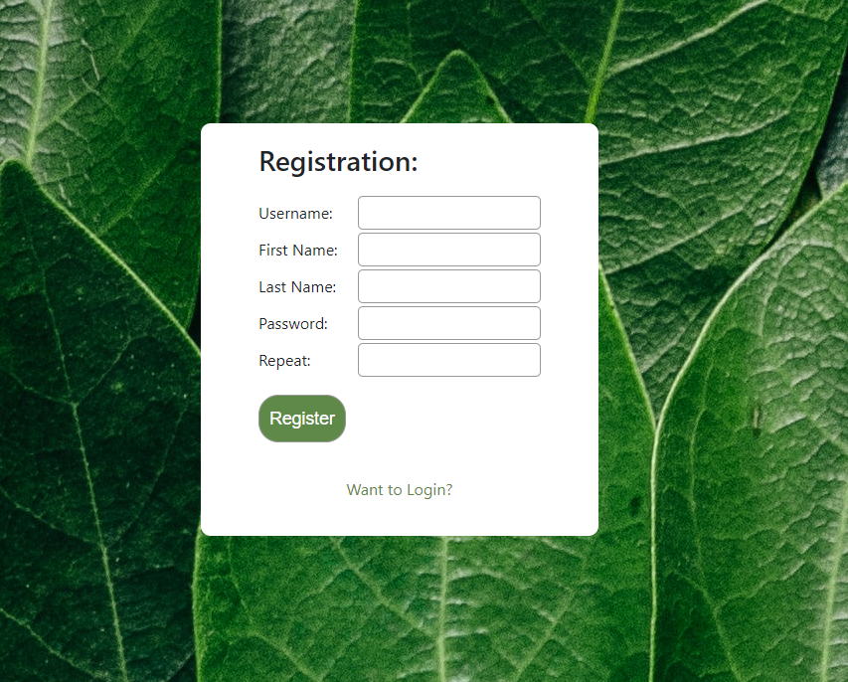

Leere Eingabe Registration

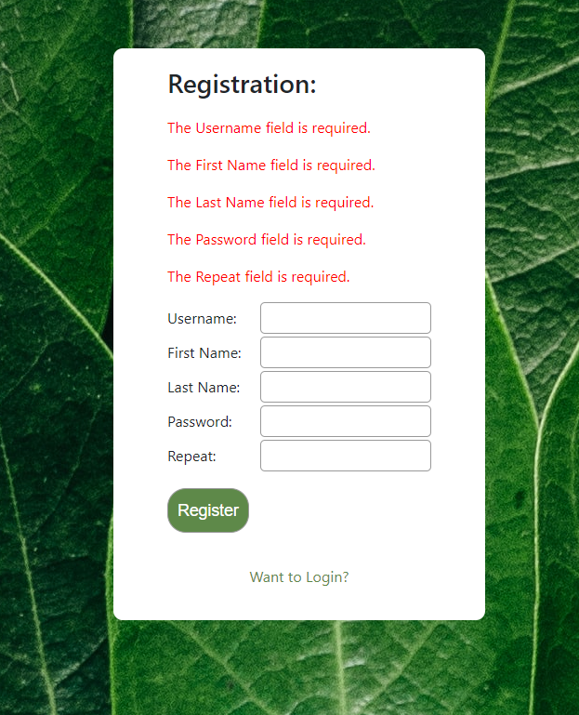

Passwort weniger als 8 Zeichen

Ein Bild, das Text enthält.

Username bereits vorhanden

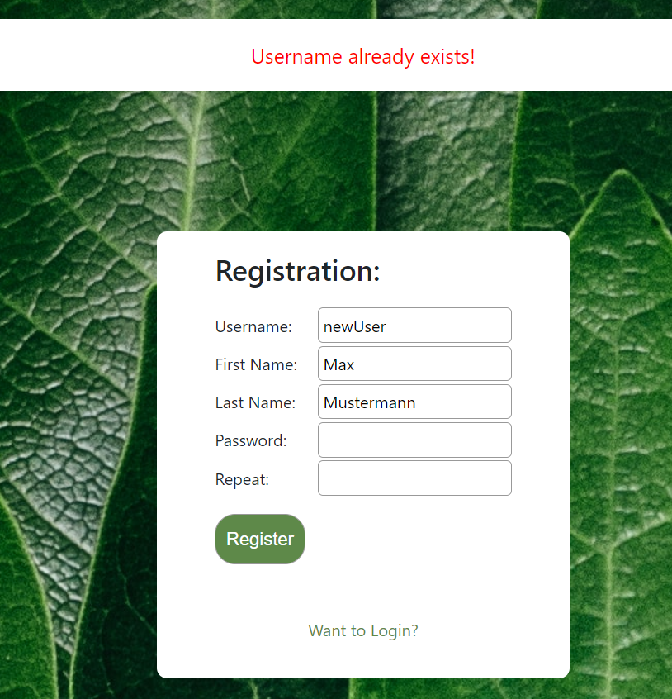

Korrekte Registrierung

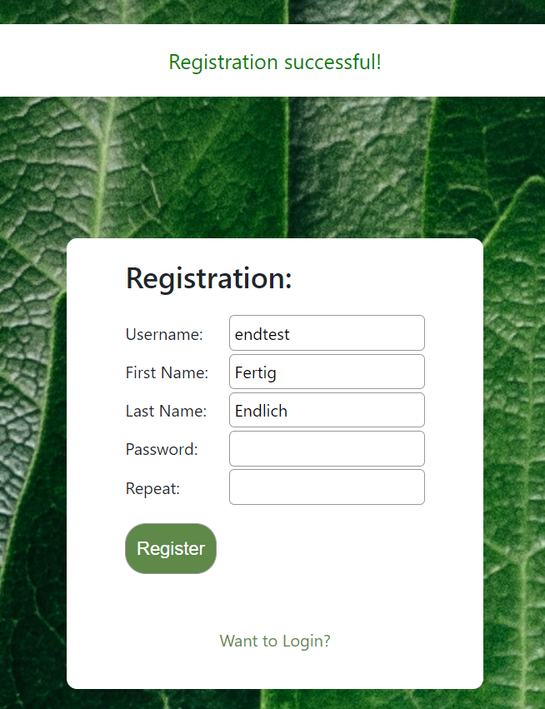

Login: Falsches Passwort

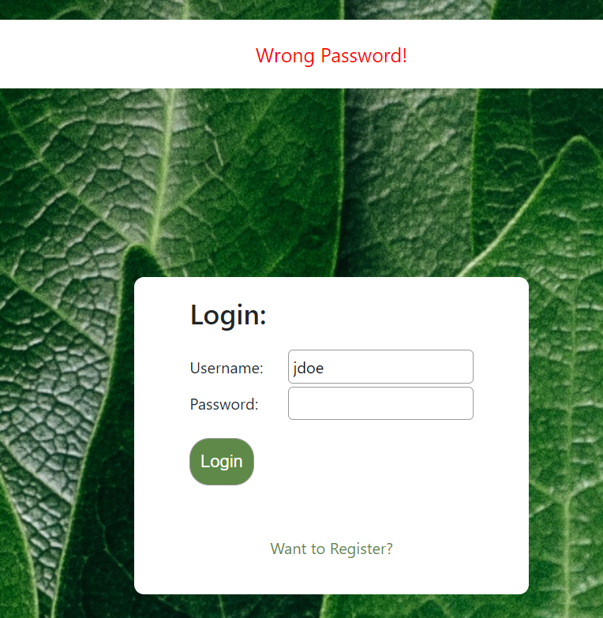

Login: Falscher Username

Ein Bild, das Text, Visitenkarte enthält.

Erfolgreicher Login

Ein Bild, das Text, grün, Pflanze, Gemüse enthält.

Logout 🡪 zurück zur Login Seite

Ein Bild, das Text enthält.
